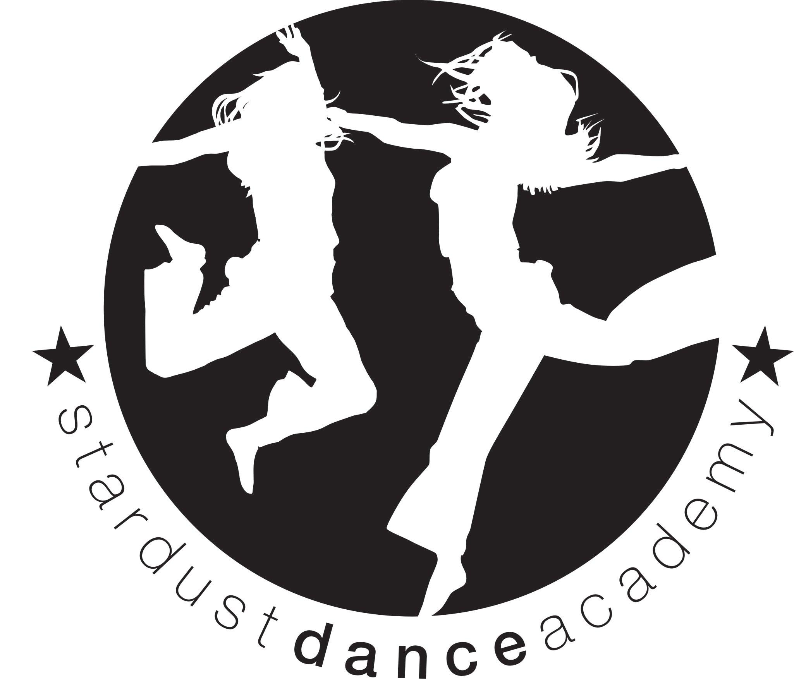
info@stardustdance.net
Carla - 07957 283 608
Beccy - 07986791999
www.stardustdance.net
Facebook: Carla Cameron (stardust dance)
Instagram: @stardustdance
Christmas Performance (12 Midday Show).
Stardust Dance Academy would like to invite you to watch your child/ren perform at our Christmas show, which will take place at Alderbrook Secondary School, Blossomfield Road, B91 1SN.
Please find the show details below:

Show date and ticket details | Show- Saturday 14th December at 12 Midday  The Show will be taking place in the MALLEY HALL. Parking and entrance are both via THE EDGE Studio.  Tickets will be on sale: Week beginning Monday 4th November. Please collect from your Dance teacher. Tickets are £7 each Please bring CASH - NO ONLINE PAYMENTS. We have 3 tickets available for each dancer.
Rehearsal | 9:30pm untll show starts £7 CASH for the rehearsal, to be paid ON THE DAY in a named envelope please.  Show starts at 12 MIDDAY
Hair and make up | Your child may arrive with make up on, but no glitter please. The school will not allow glitter. Hair - please see below.
Food/Drink | Please provide a packed lunch for your child/ren and plenty of water.  Please do NOT pack any nuts.
PLEASE FIND YOUR CLASS COSTUME REQUIREMENTS BELOW. ALL DANCERS ARE TO WEAR BLACK JAZZ SHOES/PUMPS AND BLACK SOCKS PLEASE. DANCERS-PLEASE ARRIVE IN COSTUME TO YOUR REHEARSAL>
Mill Lodge | Pink Rainbow Tutu (same as summer outfit) £26 Hair in 2 french plaits please.
Lighthall | Please See lottie for costume details
Coppice Juniors | Blue Sequin dress (from last year’s summer show) £32 and your own Halloween costumes.  Hair in 2 french plaits
Sharmans | Stardust Dance T-shirt £16 Matching legwarmers and hair bow £5
Blackwell | Purple sequin fringe dress (same as summer) . £36 Hair in 2 french plaits
Costume payments are required, in CASH in a NAMED ENVELOPE before the 25th October please and rehearsal fee is due on the day please. Please request us on Facebook to keep updated https://www.facebook.com/carla.cameron.9404…………………………………………………………………………………….
My child/ren…………………... Will/will not be attending this year’s Christmas show.
Class……………………………………………………………..
We will require 0 / 1 / 2 / 3 tickets please.
My child/ren is/ is not permitted to have their photo taken for programme .

