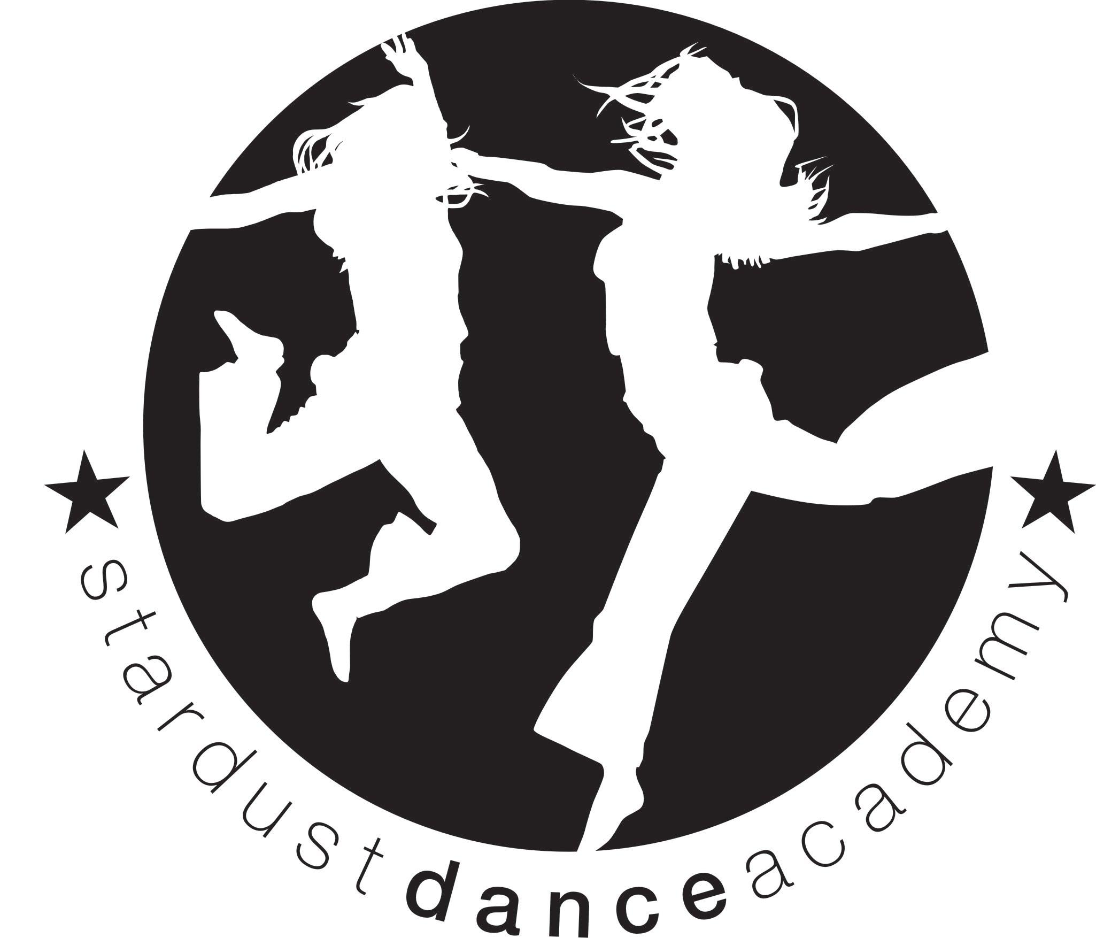
info@stardustdance.net
Carla - 07957 283 608
Beccy - 07986791999
www.stardustdance.net
Facebook: Carla Cameron (stardust dance)
Instagram: @stardustdance
Christmas Performance (10am Morning Show).
Stardust Dance Academy would like to invite you to watch your child/ren perform at our Christmas show, which will take place at Alderbrook Secondary School, Blossomfield Road, B91 1SN.
Please find the show details below:
Show date and ticket details | Show- Saturday 14th December at 10am Morning Show  The Show will be taking place in the MALLEY HALL. Parking and entrance are both via THE EDGE Studio.  Tickets will be on sale: Week beginning Monday 4th November. Please collect from your Dance teacher. Tickets are £7 each Please bring CASH - NO ONLINE PAYMENTS. We have 3 tickets available for each dancer.
Rehearsal | 8:30pm until show starts £7 CASH for the rehearsal, to be paid ON THE DAY in a named envelope please.  Show starts at 10am Morning.
Hair and make up | Your child may arrive with make up on, but no glitter please. The school will not allow glitter. Hair - please see below.
Food/Drink | Please provide a packed lunch for your child/ren and plenty of water.  Please do NOT pack any nuts.
PLEASE FIND YOUR CLASS COSTUME REQUIREMENTS BELOW. ALL DANCERS ARE TO WEAR BLACK JAZZ SHOES/PUMPS AND BLACK SOCKS PLEASE. DANCERS-PLEASE ARRIVE IN COSTUME TO YOUR REHEARSAL.
St G and T | Bright Blue sequin fringe dress (same as summer) . £36 Hair in 2 french plaits
Sutton Infants:  Sutton Juniors  Sutton Seniors | Rainbow striped tutu (same as summer outfit) and your own christmas Outfit. £30. Hair in 2 French plaits please  Blue sequin tutu and your own scary halloween costume. £30. Hair in 2 French plaits please  See Charlotte for costume.
St Pats Juniors | Kingfisher and black tutu £34 with matching leg warmers. Hair in french Platts.
St Peters Infants  St Peters Juniors | Black and pink star tutu (same as summer show) £28 Hair in high pony tail  Sequin black unitard (same as summer show) £30 Hair in 2 French plaits please.
Costume payments are required, in CASH in a NAMED ENVELOPE before the 25th October please and rehearsal fee is due on the day please. Please request us on Facebook to keep updated https://www.facebook.com/carla.cameron.9404…………………………………………………………………………………….
My child/ren…………………... Will/will not be attending this year’s Christmas show.
Class……………………………………………………………..
We will require 0 / 1 / 2 / 3 tickets please.
My child/ren is/ is not permitted to have their photo taken for programme .

