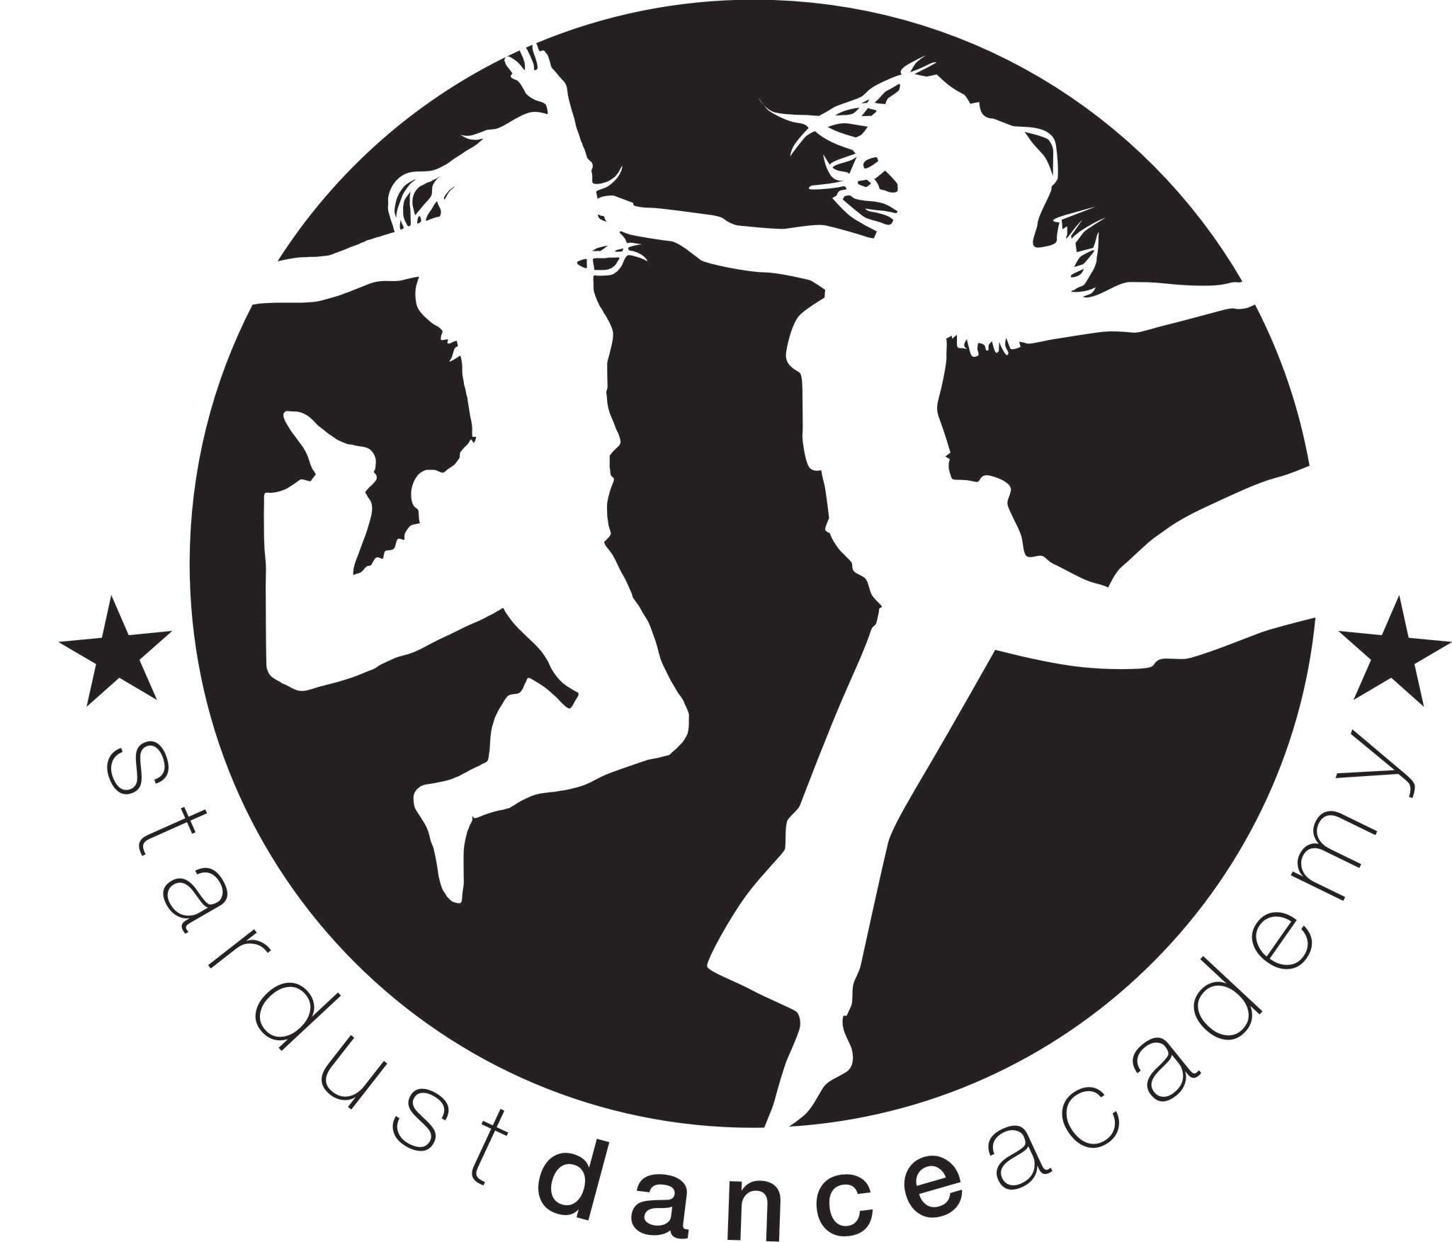
info@stardustdance.net
www.stardustdance.net
Facebook: stardustdance
Twitter: @stardust_dancer
Instagram: @stardustdance
Beccy - 07986791999

St George and St Teresa Primary School - Extra Curricular Dance / Cheerleading Club.

Stardust Dance Academy are pleased to be able to offer you the chance to join our extra curricular dance / cheerleading club. The club is held in your school music room or hall, straight after school until 4.30pm, on Thursdays and is open to children in Years 1-5. During cheerleading club, you will learn chants, lifts and stunts. Come along to learn cheerleading routines and have fun with ribbons and pom poms. You will learn modern, pop dances and cheerleading routines, in fun and friendly sessions. You will learn the core skills that dancers and cheerleaders require, including working on strength, flexibility, technique and self-confidence. Attendance at the club will enable you to have the opportunity to perform in shows and receive awards.
The clubs are open to boys and girls, with the focus being on “taking part” in the classes and getting fit in a supportive environment. Please feel free to either come along to have fun or take part in performances.
Please send comfortable clothes for your child to wear. They may wear jazz shoes or have bare feet. Please also send your child with a drink and they may bring a healthy snack.

Day | Venue | Time | Dates this term | Cost this half term
Thursdays - Year 1 - 5 | School music room/ Hall | 3:30– 4:30pm | 11th January - 29th March | £49.50
*JOIN OUR EASTER HOLIDAY CLUB 3rd - 6th APRIL @ MILL LODGE PRIMARY SCHOOL - ASK BECCY FOR MORE DETAILS*

Become our Facebook friend to keep up with the latest Stardust news https://www.facebook.com/carla.cameron.9404
and like our page Stardust Dance
How to book a club place and pay-
If you would like your child to join dance / cheerleading club as a new starter, please text Beccy on 07986791999 confirming that you will be paying by BACs or cash. Once we have received your text, you will receive a text to confirm if your child has a place. Please note that we run on a first come, first served basis and you child will be put on to our waiting list, should they not receive a place this time.

Please complete the booking slip below and send it into the school office, so that we receive it before the club starts.
You may either -
- Pay by BACs HSBC Sort code- 40 41 27. Account number- 71522744 please use your child’s name as reference
- Pay cash at the end of the first session (in a named envelope)
- PLEASE NOTE A £5 LATE FEE WILL BE ADDED IF FEES ARE NOT PAID 1 MONTH AFTER START DATE
Please do not hand money into the school and please note that due to high bank charges, cheques can no longer be accepted.

St George and St Teresa Extra Curricular Dance Club – Thursdays Jan - March 2018

Child/ren’s name(s)…………………………………………………………………………………………………………..

Contact telephone number……………………………….. Email address…………………………………..

Payment method – BACs (before the first session) / Cash (after the first session)Any medical/ other information that you feel

that we should know about your child………………………………………

