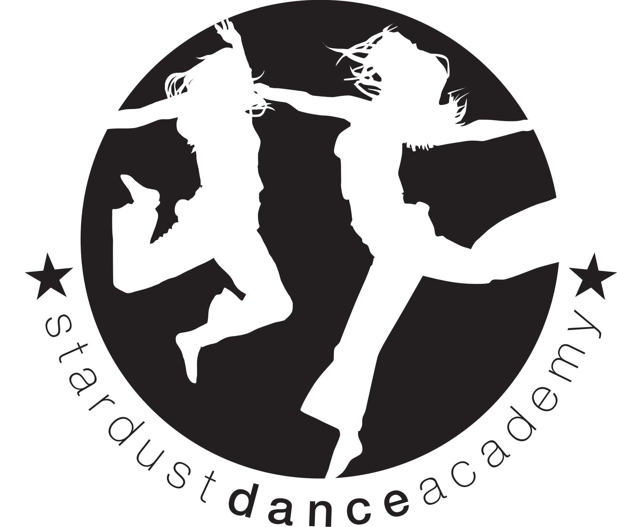
07986791999
info@stardustdance.net
www.stardustdance.net

MEDAL TEST INFORMATION

BRITISH THEATRE DANCE ASSOCCIATION.

The BTDA now require candidates to register online (Bronze only). This will enable us and them to keep accurate records of your medal test journey. To register online please follow the steps below:
- Go to http://register.gqal.org
- Enter the centre registration number 71FA0EDA
- Enter the centre post code B92 7ER
- You will now enter your child’s information
- You will not have a unique learner number yet, so please leave this blank.
- Any problems please call Beccy on 07986791999
The next medal test will take place on Saturday 28th April @ 1:30pm onwards, in the dance studio at Langley Secondary School, Kineton Green Road, Olton, Solihull, B92 7ER.

Information for dancers | You will be required to perform your solo dance that you learn in class, in front of an external examiner. You will dance in front of the rest of your group in the dance studio at Langley. Family and friends are encouraged to come along and support dancers.  You will receive a written comment sheet and medal on the day and a certificate at a later date.  Bronze, Silver and Gold medals require a routine between 1 and 2 minutes.
Costume | You are required to wear a costume and make up .You should make your costume “stand out” – no costume is too “over the top”. Use your imagination!!!!  Bright colours and hair accessories etc add to the effect!  Jazz shoes or school pumps MUST be worn  Please make sure that you do not wear any jewellery.
Cost | Bronze £27 Silver £28 Gold £30
Rehearsals  Bronze - Gold | Rehearsals in the Dance studio at Langley (address above) on the following dates:  Friday 20th April - 5:30pm - 7:00pm £6 on the day please.  28th April 10:30 - until medal test starts £6 on the day please (please arrive in costumes and bring packed lunch).
Once you have registered online (Bronze only), please bring back the form below with your medal test payment and rehearsal fee or pay by BACs: HSBC Sort code: 40 41 27 Account number: 71522744 If paying by BACs, please write the date that you paid on the slip below. Forms need to be back by 1st March 2018.

Full name (as you would like it to appear on your certificate)
Tel number

Email

Medal level you will be taking
Date of birth and age that you will be on the 28th April 2018

Signed………………………………………… Parent / Guardian. Date ………………………………….

