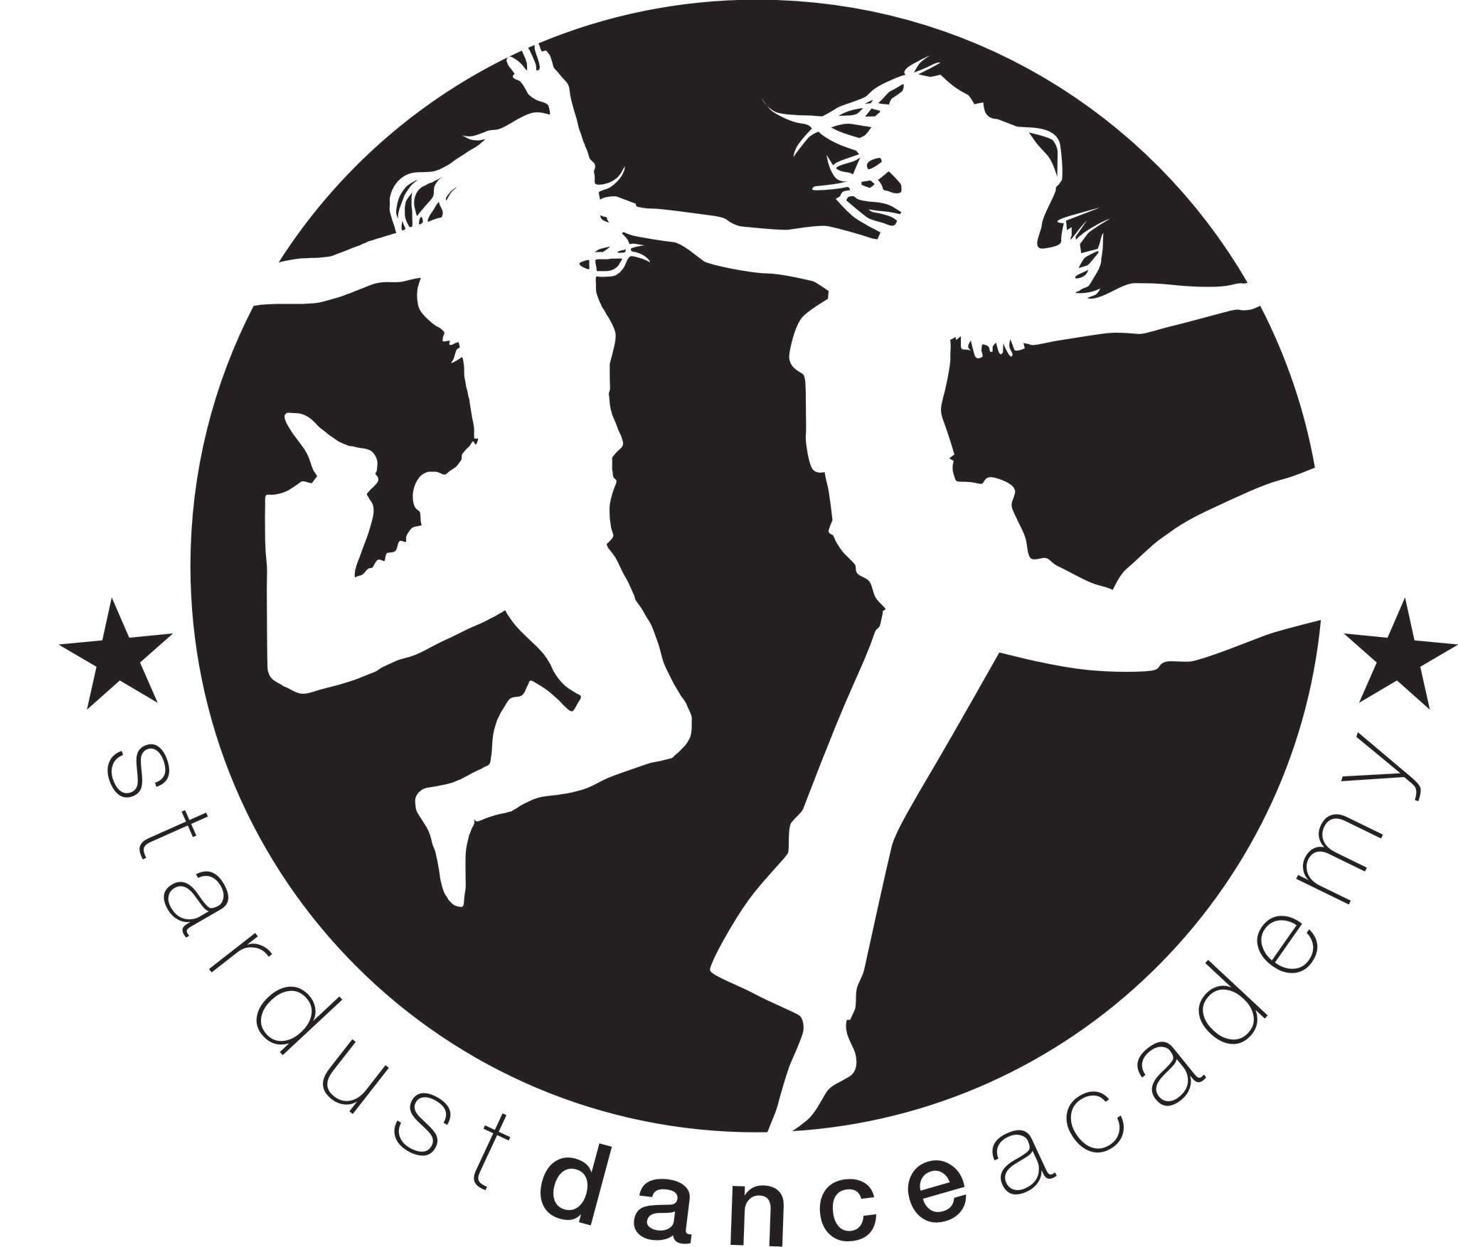
Mini Mardi & Super Mardi Performance Teams- 2019- 2020

We would like to invite your child to be part of one of our performance groups, that will be performing at the Her Majesties Theatre, West End, London on Sunday 11th October 2020. We will be taking a younger and an older group to perform in the same show, to allow siblings to perfom at the same venue on the same day. Children that are year 4 and below (in Sept 2019) will be in the younger group (Mini Mardi Team) and will rehearse from 5-6pm and children in school years 5 and up (in September 2019) will be invited to perfom with the older group, who will reharse 6-7pm. Each group will perform 2 routines, which is a great opportunity for dancers to perform in a West End theatre. The day will be a great experince for your child, should they choose to be part of this team ☺

The costs that are involved are stated below.

Tickets that are purchased directly from the theatre | Range from £29 upwards
2 Costumes | £60.00
Entrance fee that Mardi Gras charge | £15
Hair and make up | £5
Rehearsals | Rehearsals take place on Thursdays at Langley Secondary School, Kineton Green Road, Solihull, B92 7ER  (Term 1 dates) Thurs 10th October -12th December  £54.00

Mini Mardi (dancers in year 4 and below) and Super Mardi Team (dancers in year 5 and upwards).

BACs details- HSBC Sort code: 40 41 27 Account number: 71522744

Name  1 | School year group in October 2019 |  | Cash enclosed (if paying by cash)  BACs payment made
2.
Contact tel |  | Email
Additional / medical information

